**Navigating CloudWatch**

Services => CloudWatch 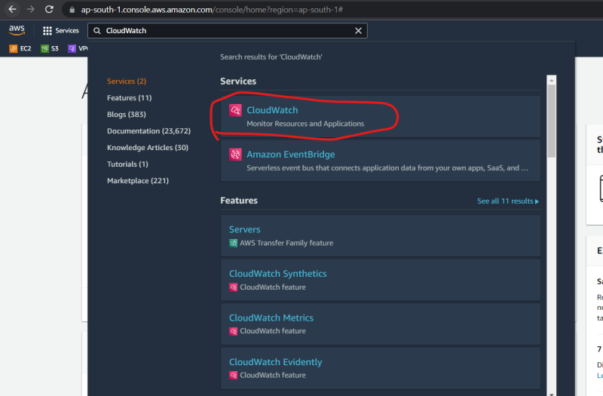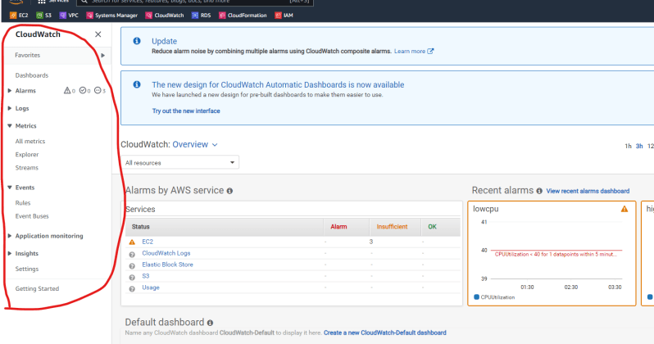

**CloudWatch Alarms**

* These are managed alert and notification service used to send notifications when anamoly is detected.
* Activity-1: Create an alarm when your ec2-instance (virtual machine on AWS) is under used

Create any linux based ec2 instance <https://www.youtube.com/watch?v=me2s3mTNwGo&list=PLuVH8Jaq3mLszrC7lv68a0VcrDripW-HK&index=2> 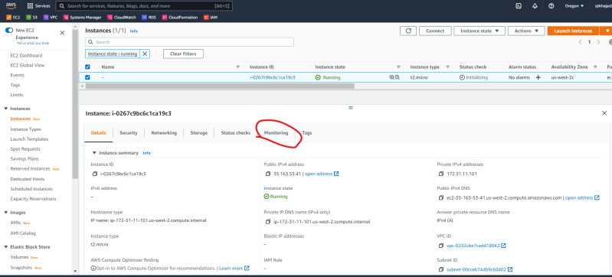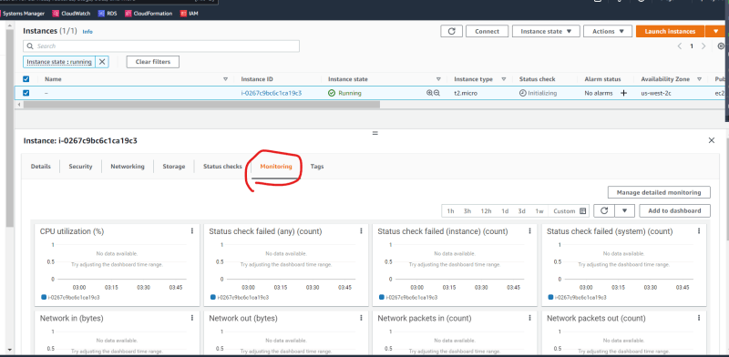

When creating metrics you need to define the condition when alarm has to be raised, which in this case is under-used

As per our organizational defintions under-used is any ec2 instance whose cpu-utilization for the last 10 minutes is less than 10%. So lets create an alarm 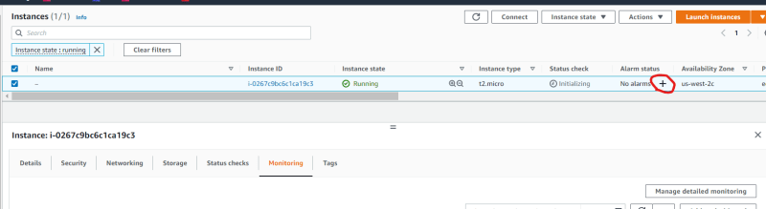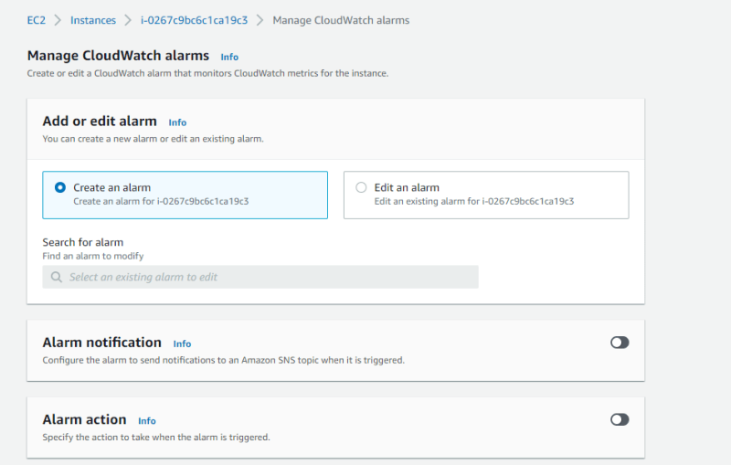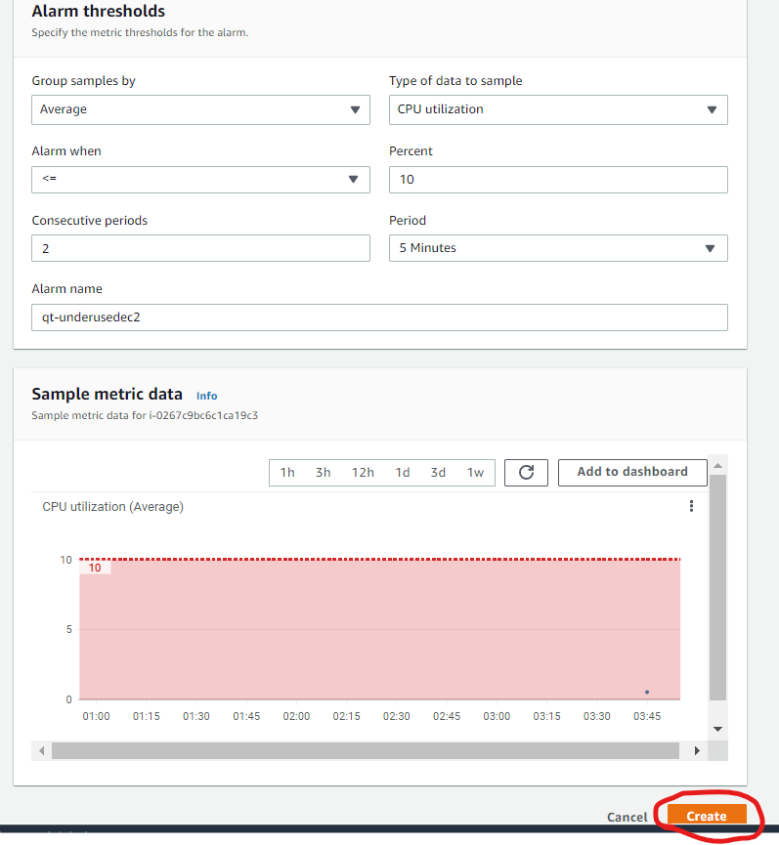

Now view the alarm 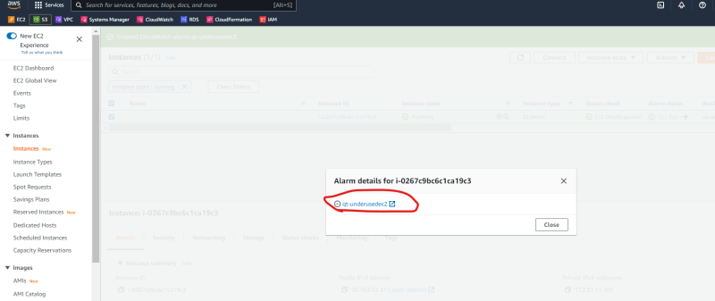

Alarm Status can be

* + - insufficient => Not enough data to find if the condition is met or not
    - OK => Condition mentioned in the alarm is not met
    - Alarm => Condition mentioned in the alarm is met

When Alarm is raised,

* + - We can manually fix the issue
    - We can send notifications
    - For some services, there can be predefined actions.

So now lets see actions w.r.t ec2 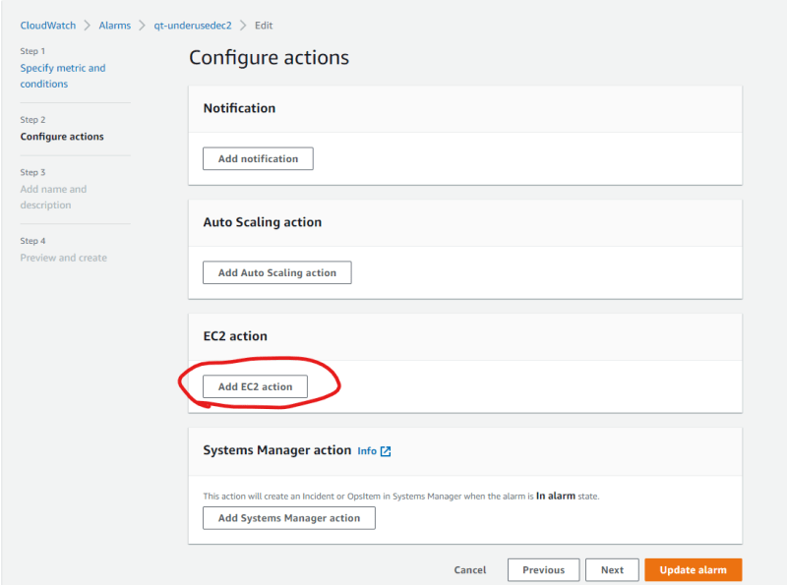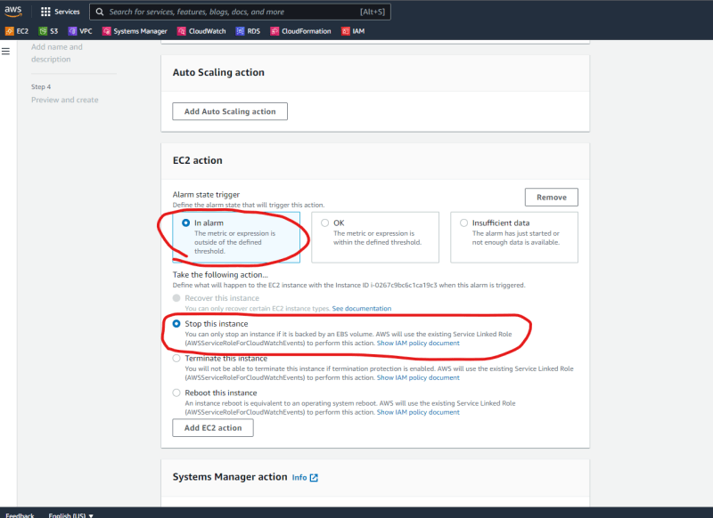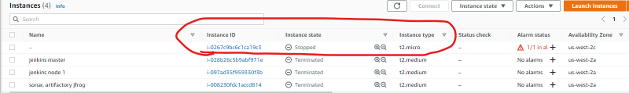

* + If you want to perform custom action which is not defined in AWS Predefined actions, then Try to create AWS Lambda function and call this from notifications
    - Since Actions are limited we can use Notifications
* Activity 2: Create an alarm which sends email when ec2 instance is underused
  + Notifications and actions: 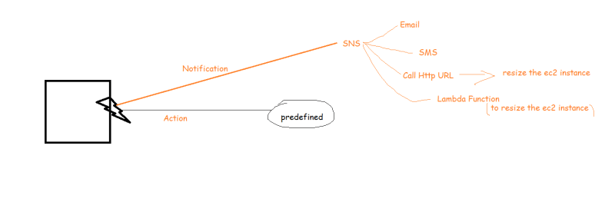

As per our organizational defintions under-used is any ec2 instance whose cpu-utilization for the last 10 minutes is less than 10% 